Counterbalance Forklift vs Reach Forklift:

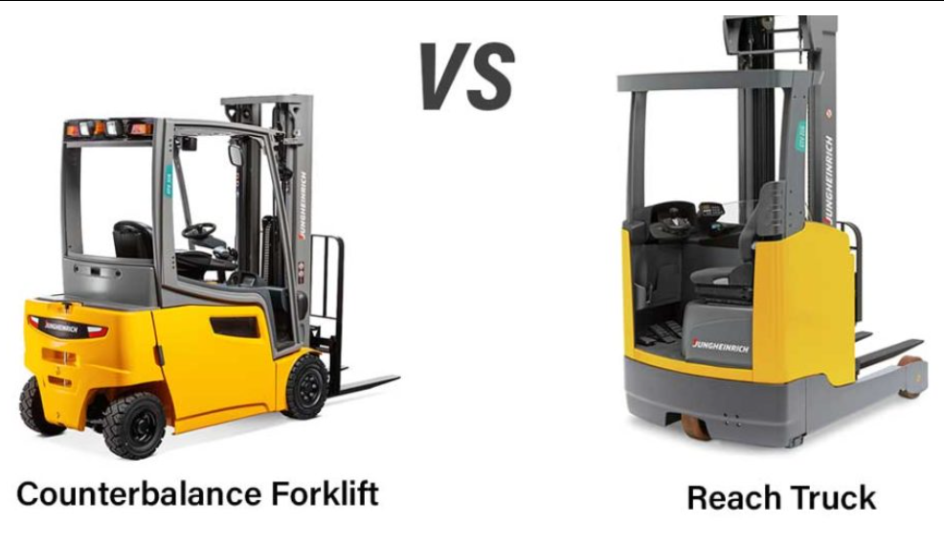

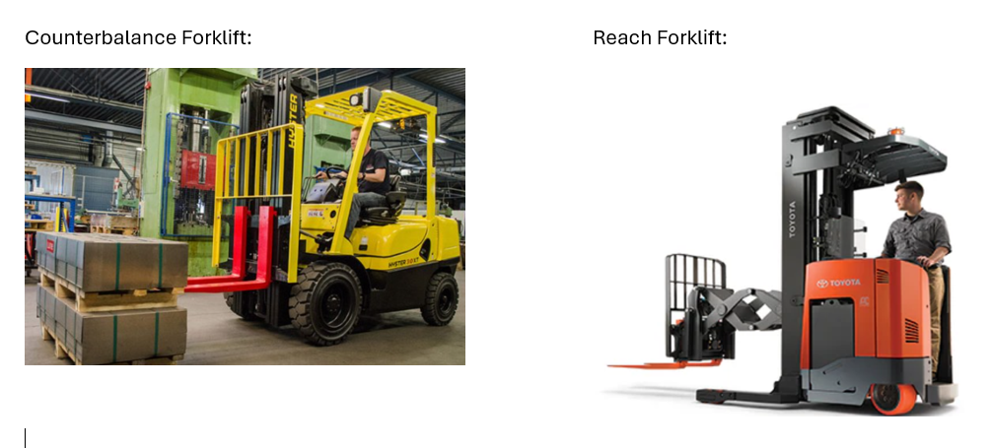

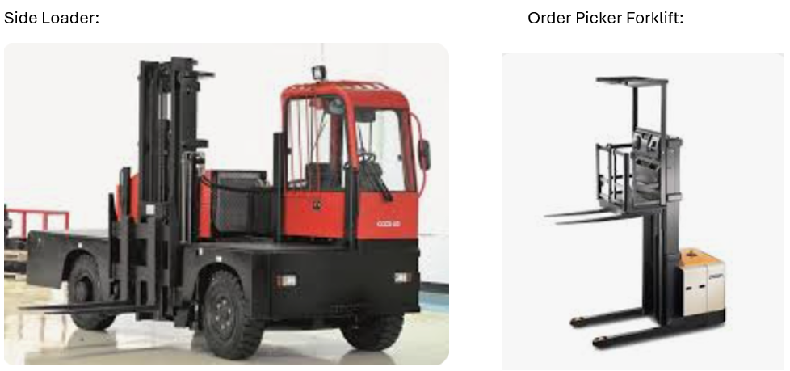

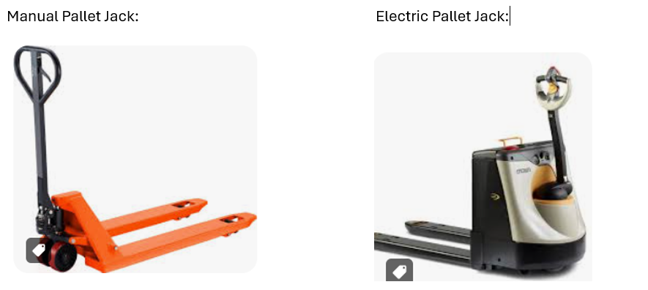

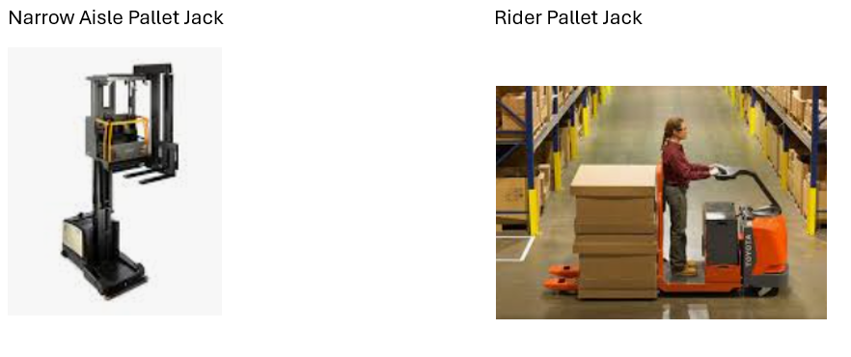

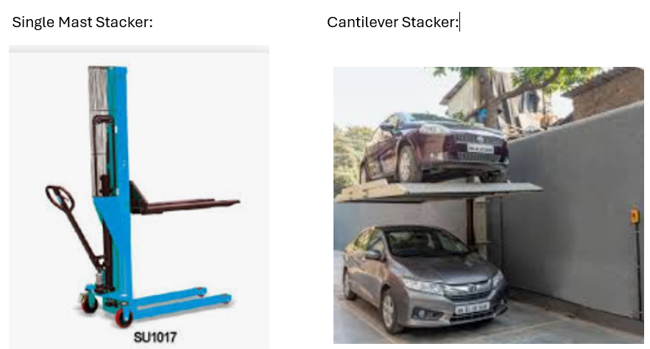

**Dock Levelers / Support Equipment:**

**Storage Equipment:**

